Artificial Neural Networks (short as neural networks) is inspired by the activity of human brains. It is composed of artificial neurons or nodes which mimics the same pattern of human brains (Hopfield, 1982).

Right now, neural networks study is the cornerstone of deep learning. Modern neural networks study is developed by threshold logic as known as McCulloch-Pitts model of neuron. It is made of two types of inputs, excitatory and inhibitory (McCulloch and Pitts, 1943).

McCulloch-Pitts model made the foundation of neural networks study, but the decision boundary is a straight line, it can only solve data set with linearly separable classes.

Rosenblatt proposed the conception of Perceptron, which made the M-P neuron model with learning ability and became the pioneer of the neural network model (Rosenblatt, 1958). By using multi-units of neurons or nodes to iterate, we can deal with non-linearly separable classes.

The model we study is a set of inputs and outputs units linked by the connection which has a weight associated. There are three layers in one model, the Input Layer, Hidden Layer and Output Layer. The model can be improved by adjusting the weight.

We demonstrate our model by using the R package neuralnet. The process can be short description as import the neuralnet library and create neural networks classifier model by passing argument set of label and features, dataset, number of neurons in hidden layers, and error calculation.

Because we have relatively large input units, it may cause over-fitting problem. To avoid the error, it would be better to choose the classic single layer neural networks model. In theory, a model with single hidden layer can estimate most of the relationship. Besides of the theory, we also tried different layers to verify the performance. The multi-layers model is not as good as the single layer one with our dataset. Hence, we focus on single layer model. We also aimed to find the variables fit well, even though removed x7(the slot variable) can performance better in our attempts, but we found that when there are 15 units with all variables in hidden layer has best performance. The Mean squared error of it is only 3698.35. It explained that the error between real price and prediction of our model is around 60.8 dollars.

We also made visualization for our neural networks model. Graph 1 below shows a neural network plot using the function in neuralnet package. We can clearly see that we have eight different inputs in inputs layer. The hidden layer computes 15 activations imply complex nonlinear transformations. The output layer is a linear model resulting a function.

**Graph 1**

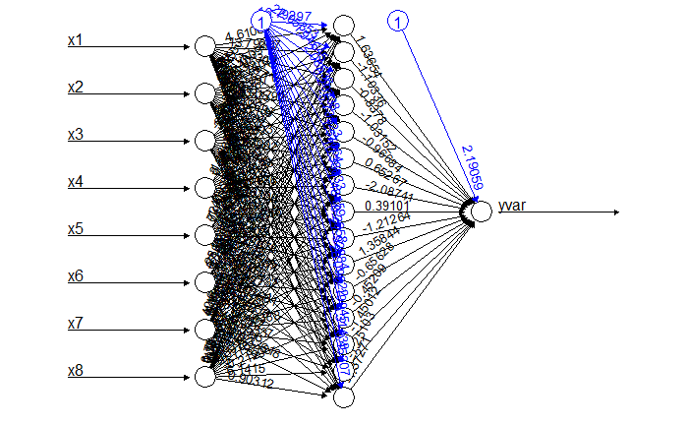

Second graph can show generalized weights (Intrator and Intrator, 1993) in our model. The overall variance is greater than it means the covariate has a nonlinear effect. The generalized weights are close to zero, it means the covariate in each variable has little effect.

**Graph 2**

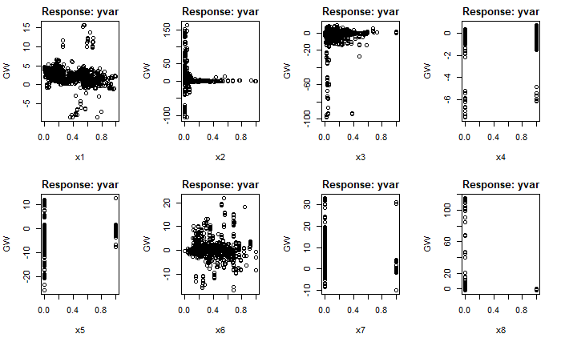

Reference:

Hopfield, J. (1982). Neural networks and physical systems with emergent collective computational abilities. *Proceedings Of The National Academy Of Sciences*, *79*(8), 2554-2558. doi: 10.1073/pnas.79.8.2554

MCCULLOCH, W., & PITTS, W. (1990). A logical calculus of the ideas immanent in nervous activity. *Bulletin Of Mathematical Biology*, *52*(1-2), 99-115. doi: 10.1016/s0092-8240(05)80006-0

Intrator O. and Intrator N. (1993) Using Neural Nets for Interpretation of Nonlinear Models. Proceedings of the Statistical Computing Section, 244-249 San Francisco: American Statistical Society (eds.)

Rosenblatt, F. (1958). The perceptron: A probabilistic model for information storage and organization in the brain. *Psychological Review*, *65*(6), 386-408. doi: 10.1037/h0042519